

**GRAB A JOB WEBSITE**

College of Information Technology and Computer Science

July 7, 2016

Abalos, Elijah James

Dongalen, Briaane

Patacsil, Mark Joshua

USE CASE DIAGRAM

Use case name: Create account

Actor(s): Applicant and Employer

Entry Condition: Clicks the create account button.

Flow of events:

Applicant:

1. Chooses the Applicant button.
2. Fill-out the needed information and click verify.
3. Opens google account for verification.
4. Clicks the verify message.
5. Click ok in the Grab Job interface.

Employer:

1. Chooses the Employer button.
2. Fill-out the needed information.
3. Clicks the ok button.

Exit Condition: Verified message will pop-out.

Use case name: Input information.

Actor: Applicant

Entry Condition: Clicks the type of job button.

Flow of events:

1. Choose what type of job and click.
2. Clicks schedule.
3. Input schedule time for work.
4. Click ok.

Exit Condition: Viewing of listed job available.

Use case name: Viewing of available job.

Actor(s): Applicant

Entry Condition: Applicant clicks ok and display the listed job.

Flow of events:

1. Chooses appropriate job.
2. Clicks the chosen job.
3. Check if still available.
4. Click ok.

Exit Condition: Display send a resume button.

Use case name: Sending resume.

Actor: Applicant

Entry Condition: Applicant clicks the send resume button.

Flow of Events:

1. Fill-out resume form.
2. Checks if the resume is valid.
3. Click ok
4. Clicks save and submit.

Exit Condition: Display Save and submitted.

Use case name: Input job available.

Actor: Employer

Entry Condition: Click add job button.

Flow of events:

1. Selects what type of job will be offered.
2. Fill-out the Job offer form.
3. Check if the information is valid.
4. Click ok.

Exit Condition: Display Job offer added.

Use case name: Verify resume.

Actor: Employer

Entry Condition: Click Verify resume button.

Flow of events:

1. Clicks view resume sent button.
2. Checks the resume if valid.
3. Click send a message.
4. Write a confirmation letter.
5. Click send.

CLASS DIAGRAM

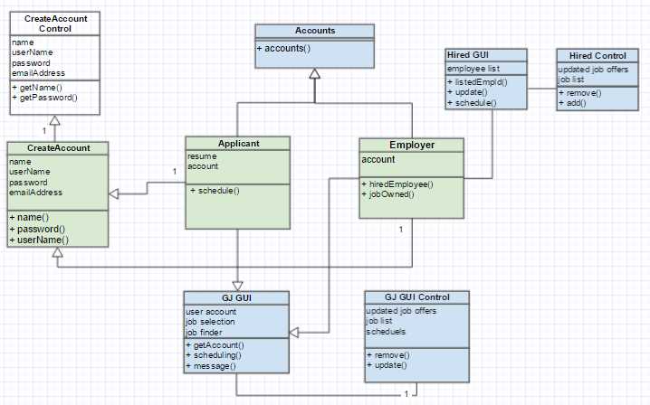

This diagram shows how the classes interact to each other. The Applicant will input information by creating an account and passes the information to the create account control and saves it to the account class. the applicant will now sign-in its account and will be able to select a job to the GJ GUI and sends its information to the employer account. The Employer will now validate the Applicant information and it will now store its information to the Hired Control.

SEQUENCE DIAGRAM

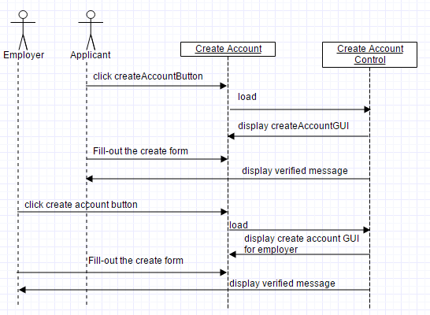**Sequence Diagram for Create Account**

**Sequence Diagram for Input Information**

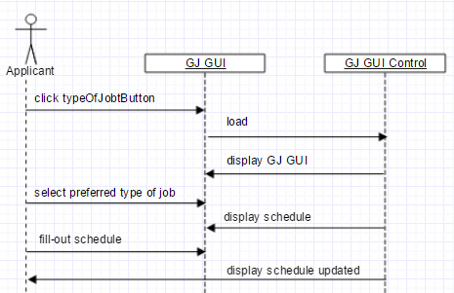

**Sequence Diagram for Viewing of available job**

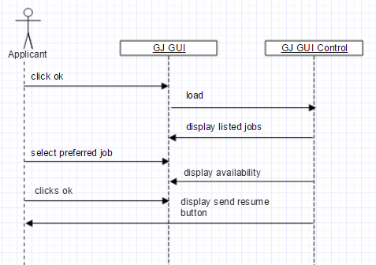

**Sequence Diagram for Sending resume**

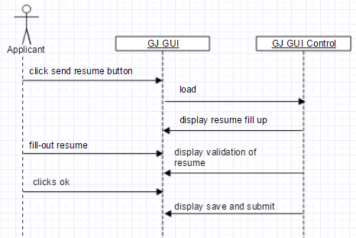

**Sequence diagram for Input Job**

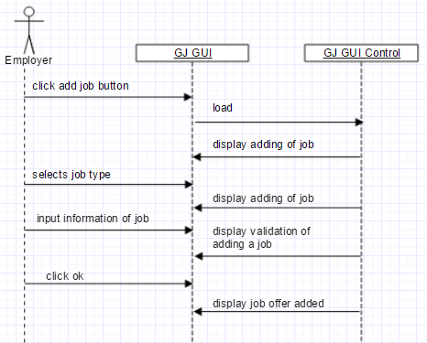

**Sequence Diagram for Verify resume**

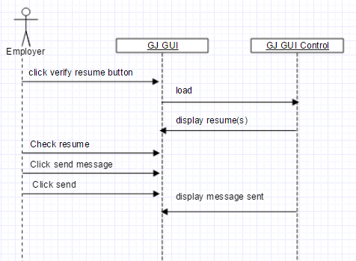

The diagrams above show how the user and the system interacts to each other. This also shows the sequential flow of events when a user interacts into the system. The user will just click and input its data and the system will respond onto the request of the user. The system will also save the data of the user for backup.

PACKAGE DIAGRAM

APPLYING

ONLINE

ACCOUNT

INPUT INFORMATION

CREATE ACCOUNT

AVAILABILITY

CONFIRMATION

SENDING OF RESUME

To enable the application to run, it has a three (3) packages. The first package is the applying package this will be the process where the user applies for a job using the Grab a Job website. The second part is Account package is where they will create an account to secure and validate personal information. Lastly, the availability that represents the process of sending resume for the available job. These three represents the applying transaction.

DEPLOYMENT DIAGRAM

USER/APPLICANT

WEB SERVER

SERVICE

AVAILABILITY

This Grab a Job website communicates with the people who are looking for a site that are suitable or capable for finding a job. They can access this by using the web server. As the user finish applying, the user waits for confirmation that is given by the employer which are looking for an employee.